Name: Pranali Sonawane
Subject: MCSA
Date: 11-12-2025
Lab: Group Policy

DNS Task 1 : Uninstall dns from server 2 , restart machine , install DNS again on server 2 , configure stub zone.

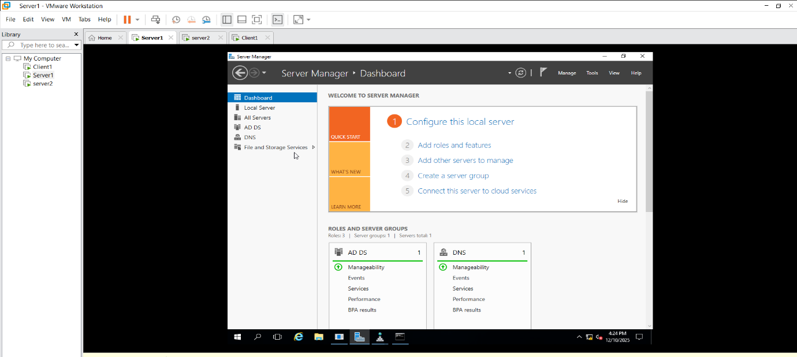

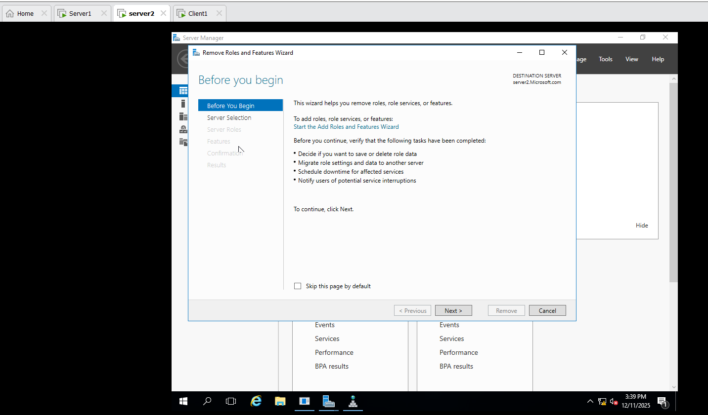
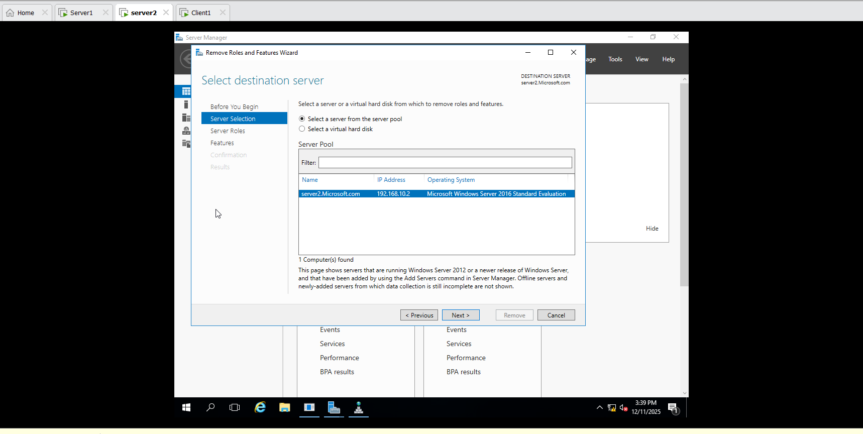
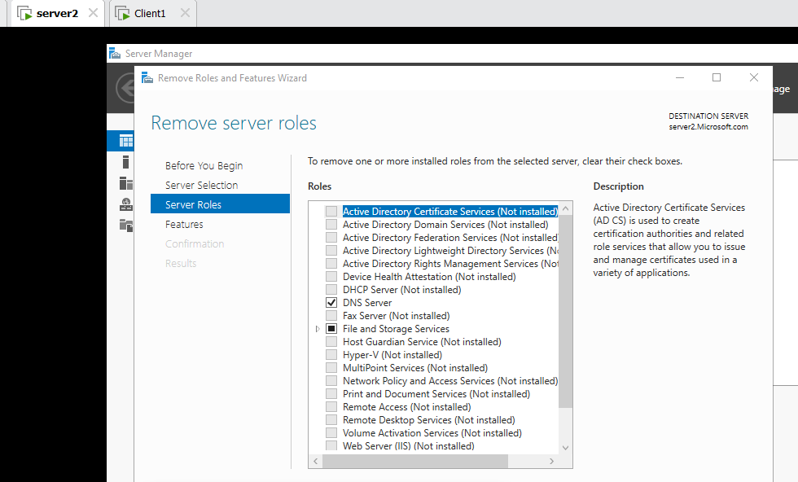
Install Dns Server2 Restart Server2
Configure stub zone:
Tools Click on DNS Click on Server1 Create New Zone Stub Zone next Network ID: 192.168.10 next
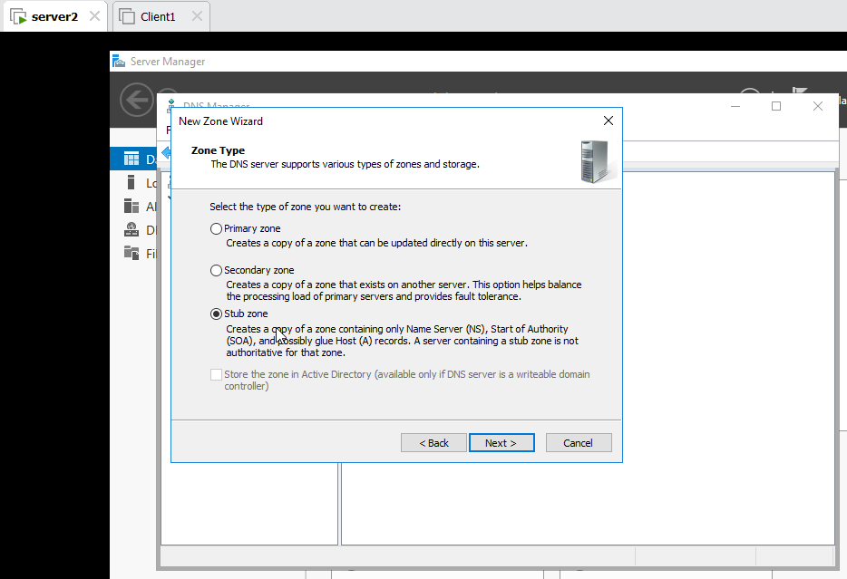

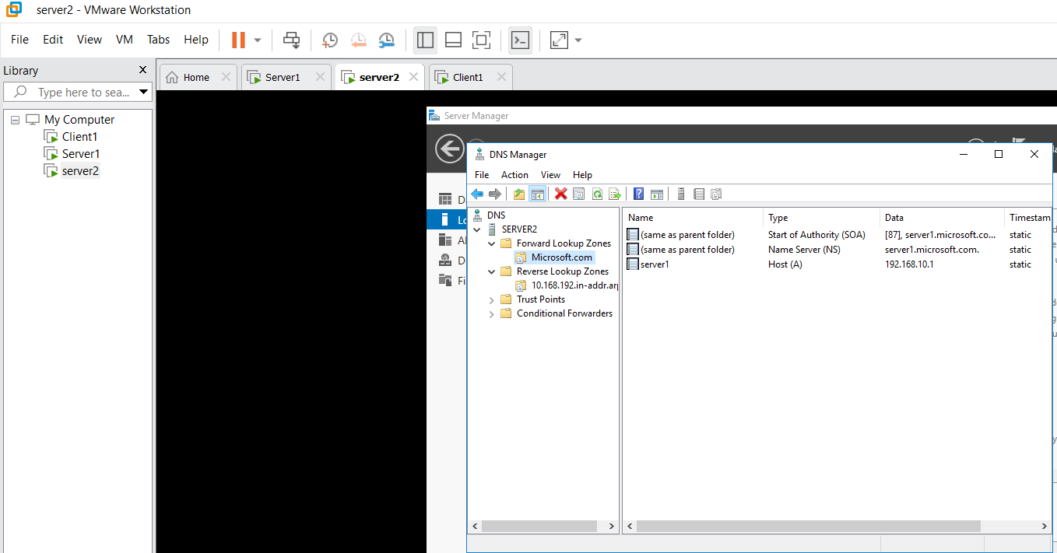
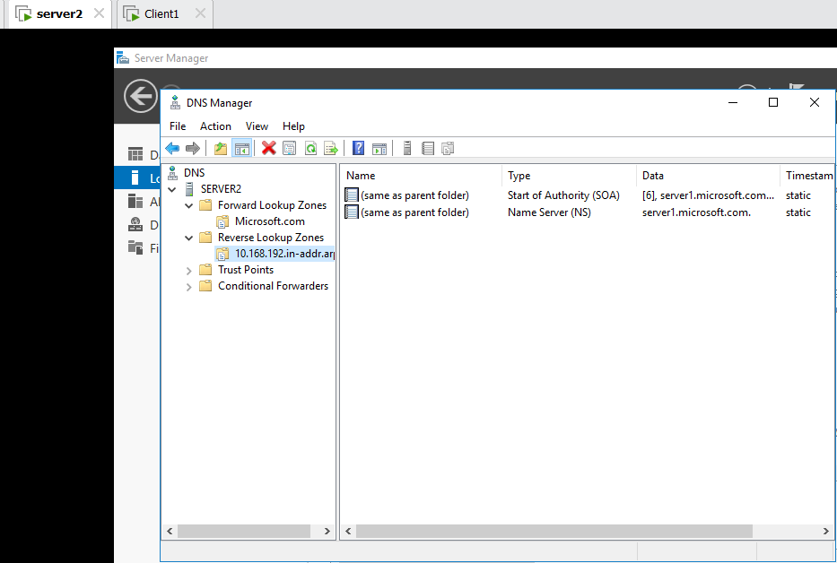
Group Policy:
Server1: Tools Active Directory User and Computer Server1 Microsoft.com New OU (organizational Unit ) Name HR then Create 3 User HR1,HR2,HR3

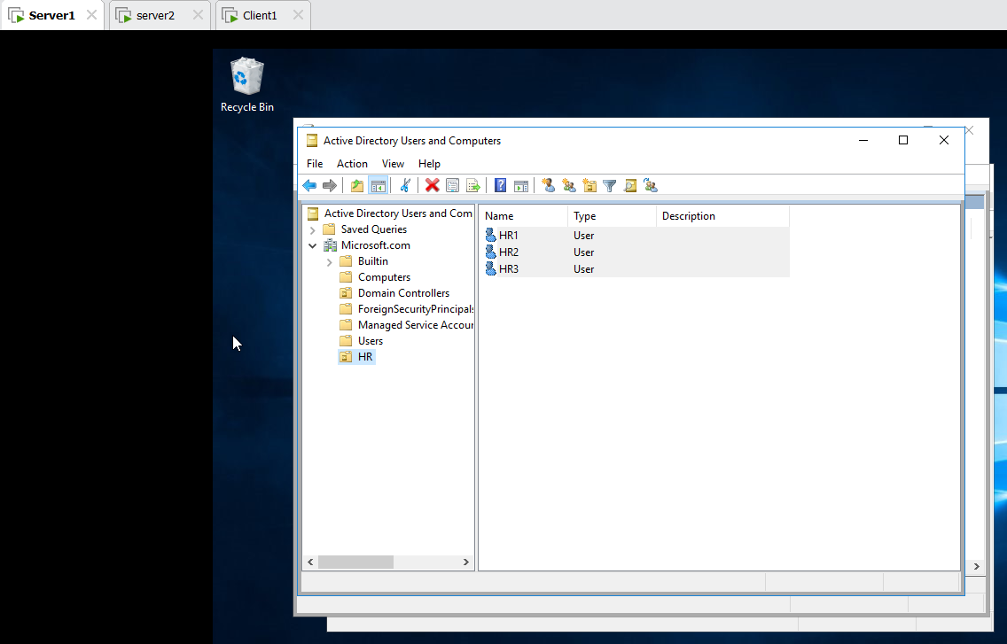

Tools Group Policy Management Microsoft.com HR Create GPO HR edit User Config Administrative Template Click on Start Menu and Taskbar At Bottom Click on Standard Remove Run Menu for Start Menu enabled 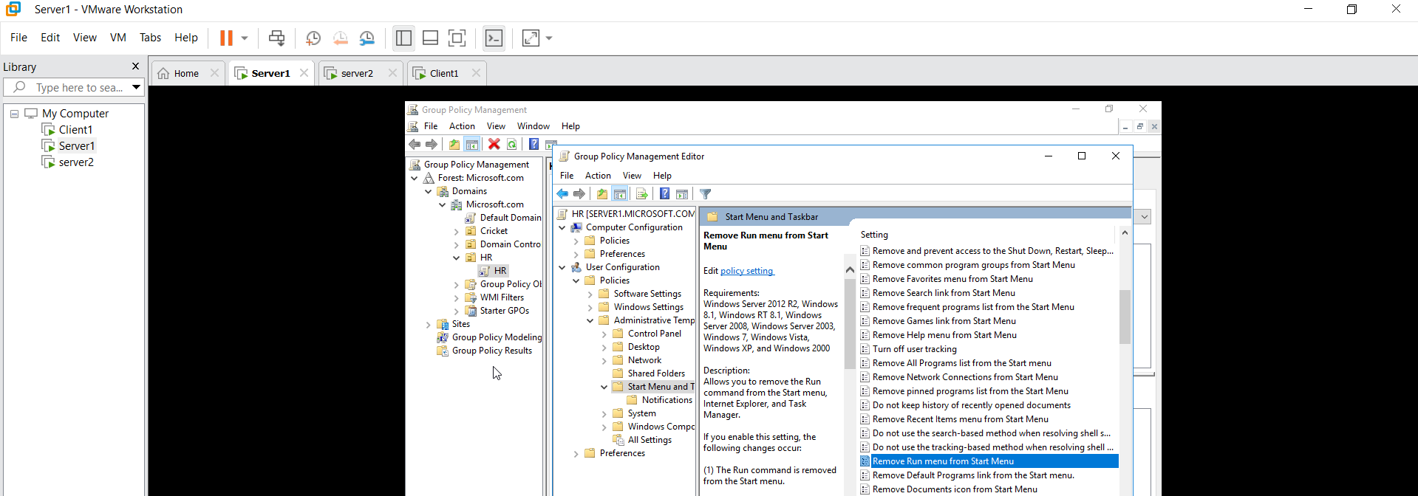
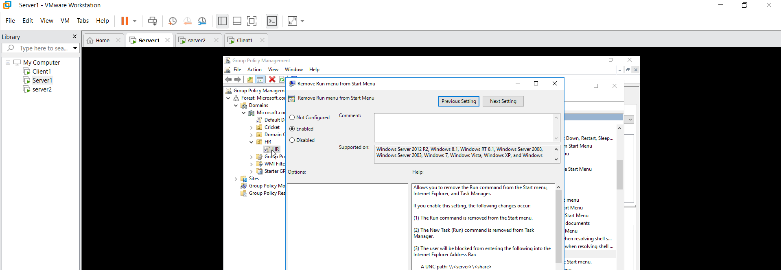Check on Client 1 Login HR1
After Login Run Error show
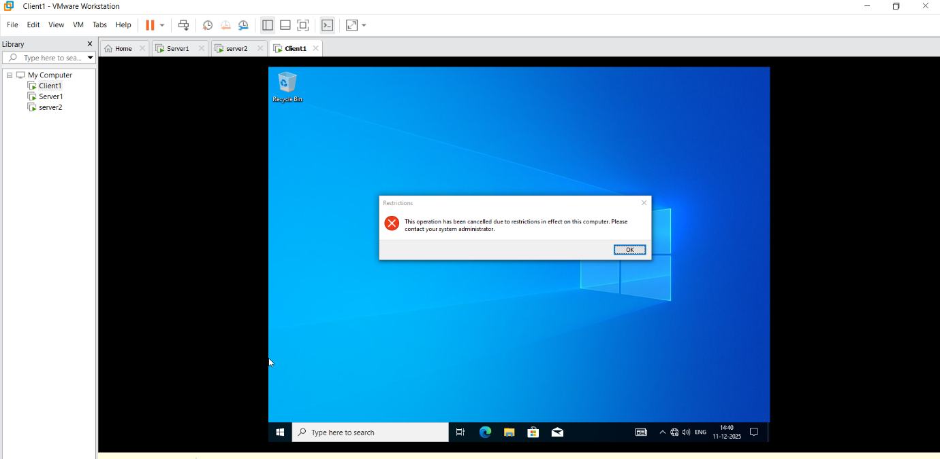
Client1 Login User Server1 user login such as shiv , Abhi, Pooja Run MsPaint
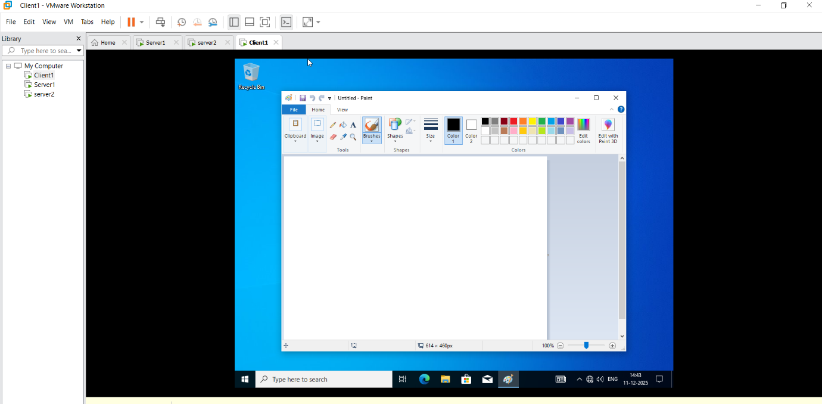

Server1: Tools Active Directory User and Computer Server1 Microsoft.com New OU (organizational Unit ) Name Cricket then Move 3 User Shiv , Pooja , Abhi
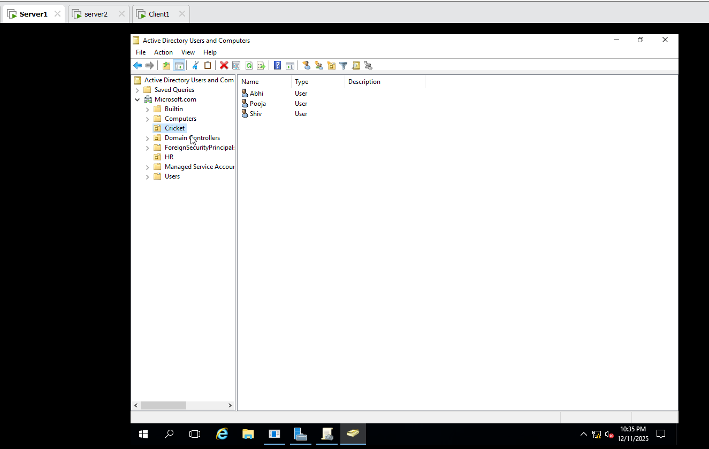
Tools Group Policy Management Microsoft.com Cricket Create GPO Cricket edit User Config Administrative Template Click on Start Menu and Taskbar At Bottom Click on Standard Remove Recycle bin from Desktop enabled
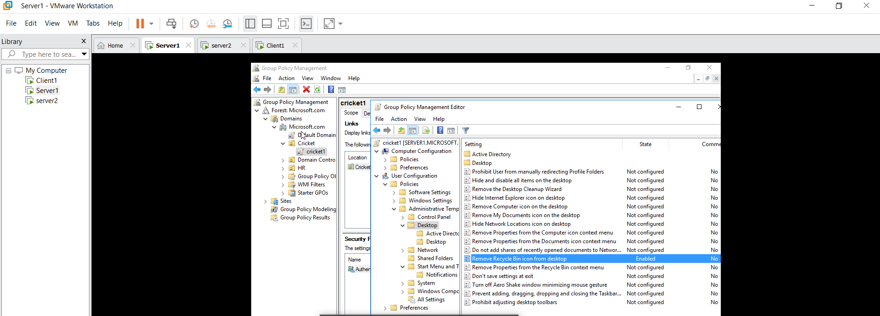

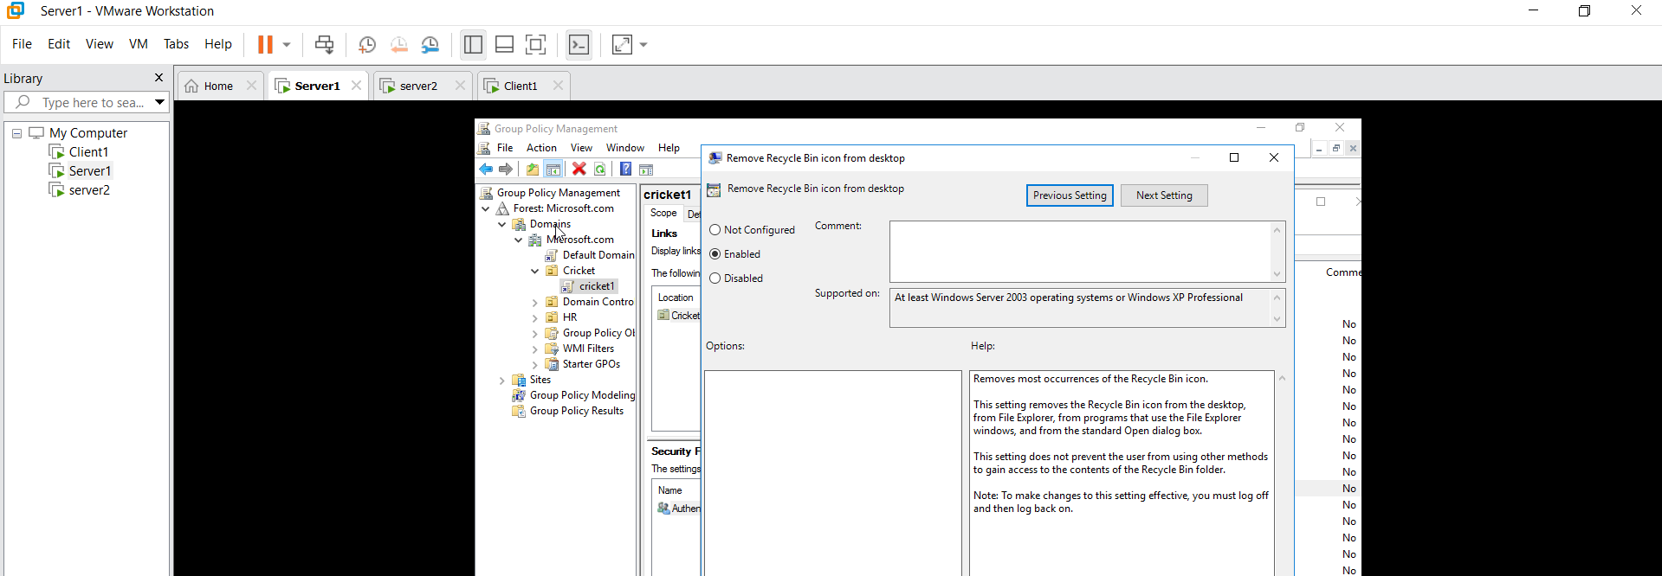
Check on Client 1 Login Abhi Recycle bin not show.

Task on Group Policy :
Group Policy Microsoft.com Lock all Taskbar Enabled
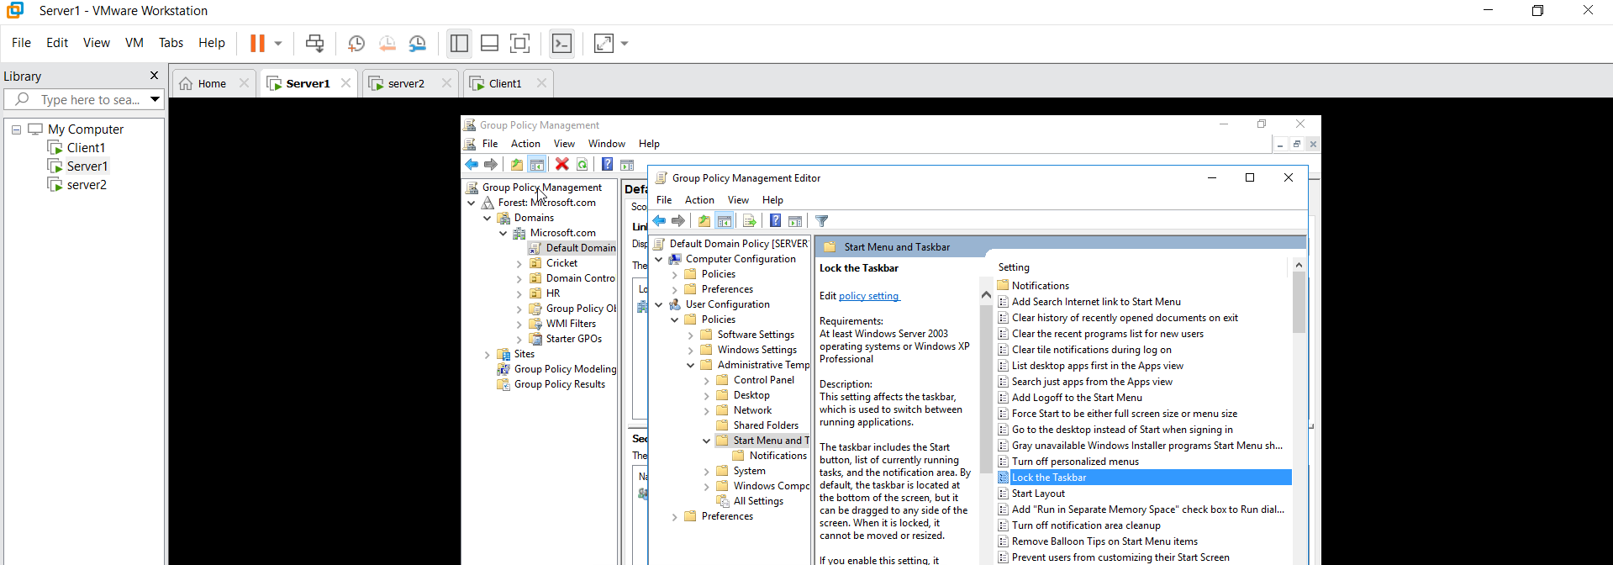
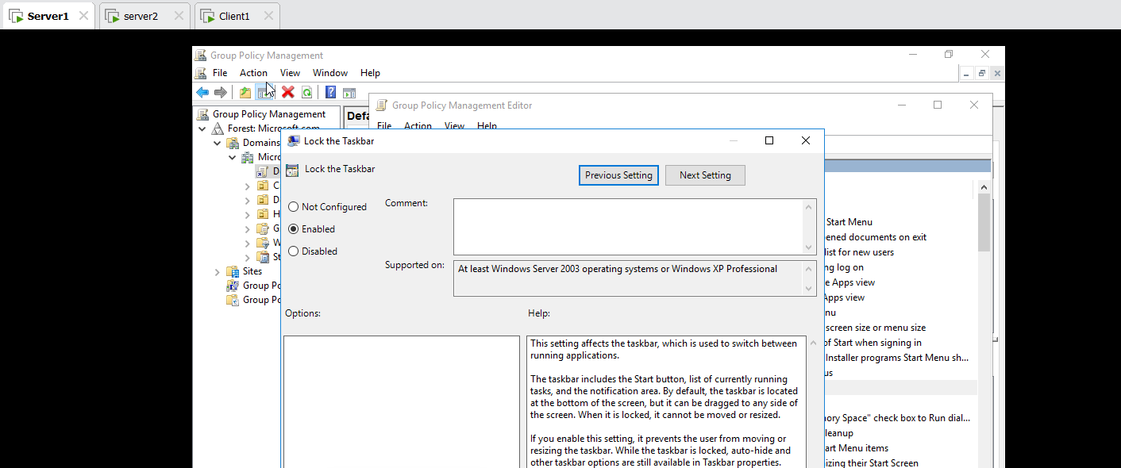
Microsoft.com Cricket Enter Cricket Edit Lock all Taskbar Disabled 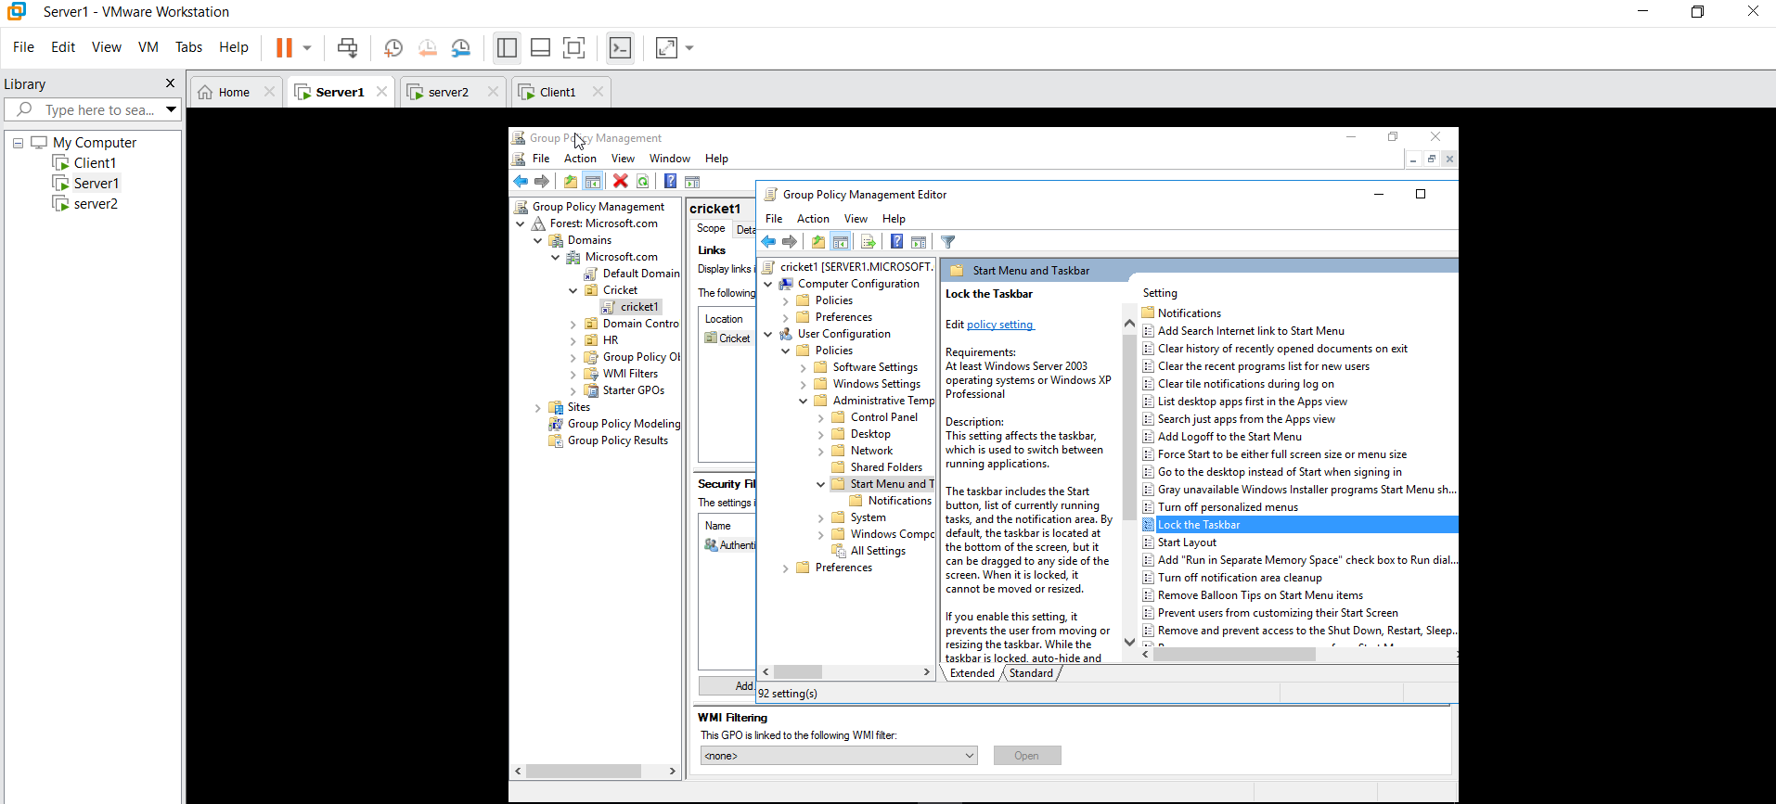
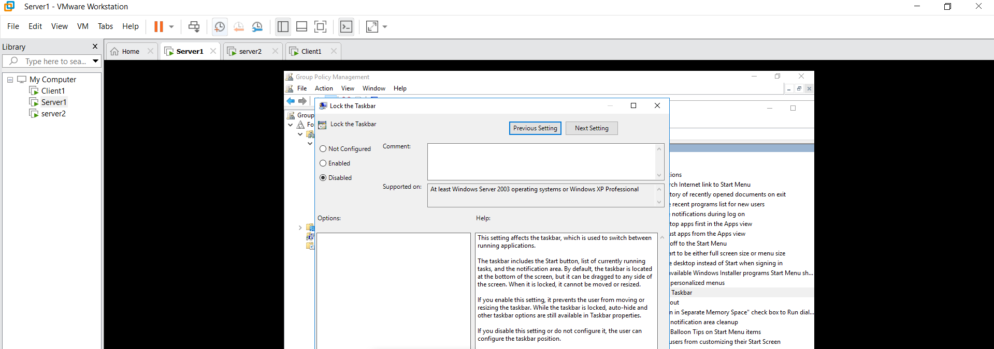

Client1 Login Abhi
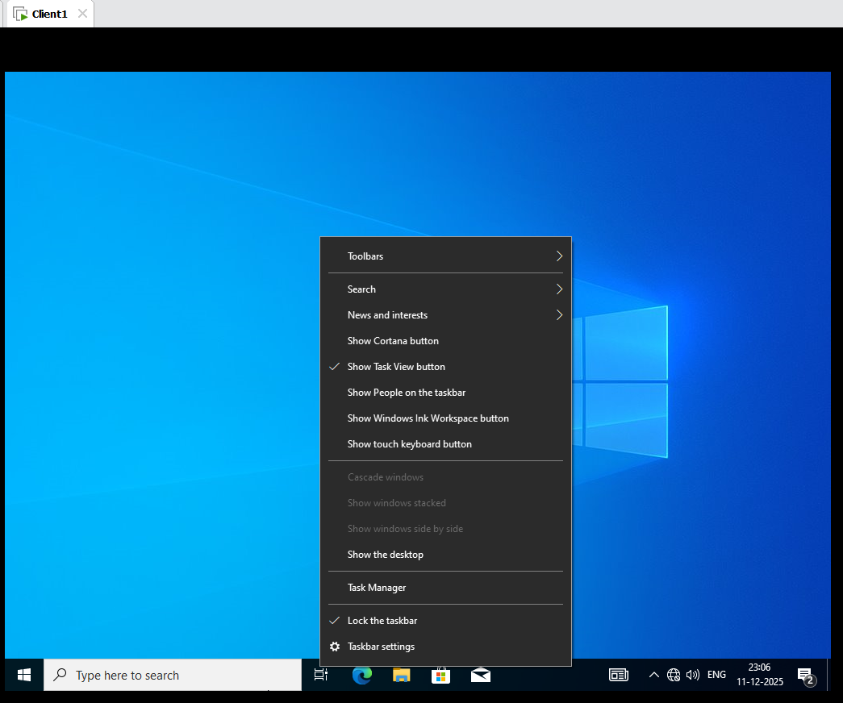

Client1 Login HR1

